Add constraint : DeptCode of Student is foreign key with reference to DeptCode in
Department.
ALTER TABLE STUDENT ADD FOREIGN KEY(DEPTCODE) REFERENCES DEPARTMENT(DEPTCODE);
SELECT CONSTRAINT_NAME,SEARCH_CONDITION, CONSTRAINT_TYPE FROM USER_CONSTRAINTS WHERE TABLE_NAME='STUDENT';
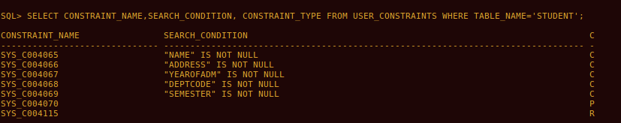

SELECT CONSTRAINT_NAME,SEARCH_CONDITION, CONSTRAINT_TYPE FROM USER_CONSTRAINTS WHERE TABLE_NAME='DEPARTMENT';
Add an attribute Block to the department table (data type - Char).
ALTER TABLE DEPARTMENT ADD(BLOCK CHAR(2));
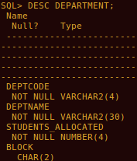

Insert data to this attribute.
UPDATE DEPARTMENT SET BLOCK='C' WHERE DEPTCODE='CSE' OR DEPTCODE='IT';
UPDATE DEPARTMENT SET BLOCK='B' WHERE DEPTCODE='ECE' OR DEPTCODE='EE';
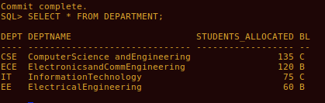

Increase the width of the column subject code of SUBJECT table to 8.
alter table subject modify(subjectcode Varchar2(8));
Delete primary key of table of Subject.
ALTER TABLE SUBJECT DROP CONSTRAINT SYS_C004104;
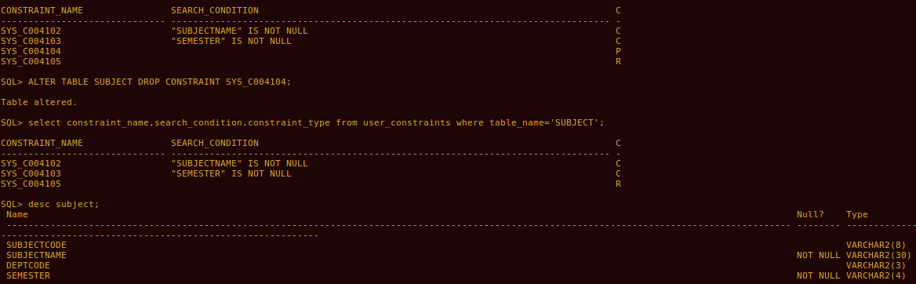
Add primary key to the table subject.
ALTER TABLE SUBJECT ADD CONSTRAINT PK1234 PRIMARY KEY(SUBJECTCODE);
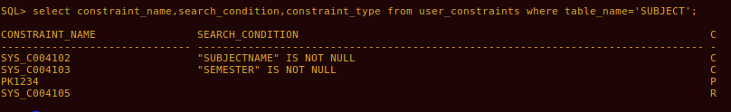
Make Sub_code of Result table foreign key with respect to Subject code of SUBJECT
table.
ALTER TABLE RESULT ADD FOREIGN KEY(SUB_CODE) REFERENCES SUBJECT(SUBJECTCODE);
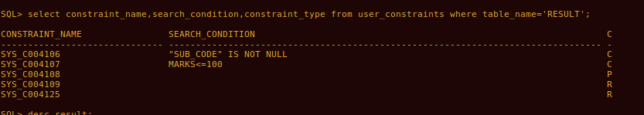
Add constraint that marks cannot be negative.
ALTER TABLE RESULT ADD CONSTRAINT A1234 CHECK (MARKS>=0);
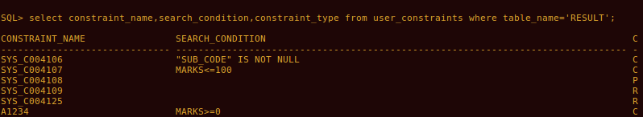
Alter the table DEPARTMENT and add check constraint such DeptCode is either CSE,IT,
MCA, EE, ECE
ALTER TABLE DEPARTMENT ADD CONSTRAINT B1234 CHECK(DEPTCODE='CSE' OR DEPTCODE='IT' OR DEPTCODE='MCA' OR DEPTCODE='EE' OR DEPTCODE='ECE');
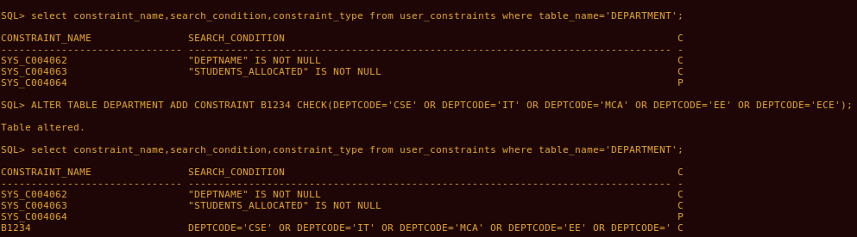
Add the college phone number (25739607) to each of these students.
ALTER TABLE STUDENT ADD(COLLEGEPHONENO NUMBER(8));
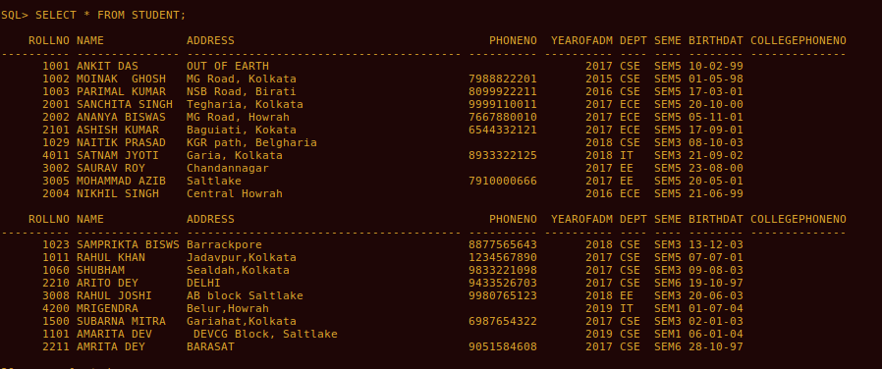
UPDATE STUDENT SET COLLEGEPHONENO=25739607;
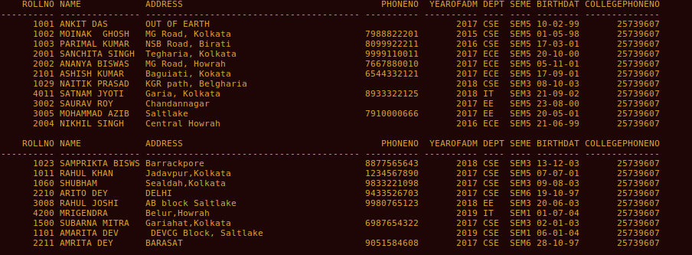
Create a table FACULTY (FID VARCHAR2(4), Name VARCHAR2(20)); Faculty id
should start with ‘F’.
CREATE TABLE FACULTY (FID VARCHAR2(4), NAME VARCHAR2(20) NOT NULL, CHECK (FID LIKE 'F%'));
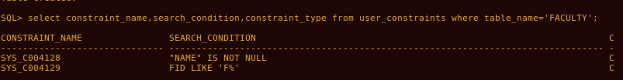
Insert values to the table Faculty.
INSERT INTO FACULTY VALUES('F01','Aloke Kumar Dutta');
INSERT INTO FACULTY VALUES('F02','Abhijit Roy');
INSERT INTO FACULTY VALUES('F03','Probal Kumar');
INSERT INTO FACULTY VALUES('F04','Mousumi Dey');
INSERT INTO FACULTY VALUES('F05','Sharmistha Nag');
INSERT INTO FACULTY VALUES('F06','Dipti Bhattacharya');
INSERT INTO FACULTY VALUES('F07','Sanjay Kumar Das');
INSERT INTO FACULTY VALUES('F08','Partha Pratim Ba');
INSERT INTO FACULTY VALUES('F09','Rakesh Chouhan');
INSERT INTO FACULTY VALUES('F10','Srija Paul');
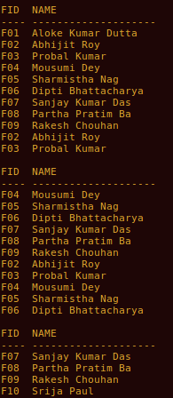

Insert column pass marks in subject table and add values to this column.
ALTER TABLE SUBJECT ADD (PASSMARKS NUMBER(2));
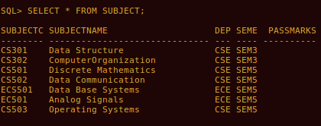

SELECT * FROM SUBJECT;
UPDATE SUBJECT SET PASSMARKS=40;
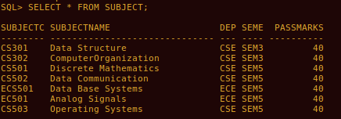

Delete the column pass marks from Result.
ALTER TABLE RESULT DROP COLUMN PASSMARKS;
